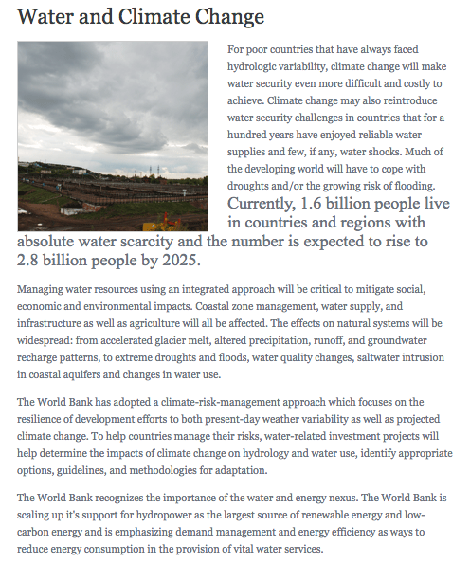

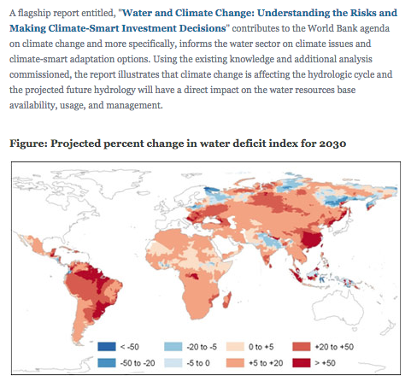

Source:

http://water.worldbank.org/topics/water-resources-management/water-and-climate-change

